Cab Fare Prediction

Abinash Pradhan

Contents

 | Introduction | 3
 | Problem Statement | 3
 | Data | 3
 | Methodology | 4
 | Pre-Processing | 4
 | Removing values which are not within desired range (outlier) depending upon basic understanding of dataset. | 12
 | Outlier Analysis | 12
 | Missing Value Analysis | 13
 | Feature Engineering | 16
 | Feature Selection | 18
 | Feature Scaling | 22
 | Splitting train and test Dataset | 24
 | Hyperparameter Optimization | 24
 | Model Development | 25
 | Improving accuracy | 27
 | Finalize Model | 27
 | Complete Python Code | 28
 | Complete R Code | 70

Chapter 1
Introduction

  - Problem Statement

The objective of this project is to predict Cab Fare amount. You are a cab rental start-up company. You have successfully run the pilot project and now want to launch your cab service across the country. You have collected the historical data from your pilot project and now have a requirement to apply analytics for fare prediction. You need to design a system that predicts the fare amount for a cab ride in the city.

  - Data

Attributes: ·
    - pickup_datetime - timestamp value indicating when the cab ride started.
    - pickup_longitude - float for longitude coordinate of where the cab ride started.
    - pickup_latitude - float for latitude coordinate of where the cab ride started.
    - dropoff_longitude - float for longitude coordinate of where the cab ride ended.
    - dropoff_latitude - float for latitude coordinate of where the cab ride ended.
    - passenger_count - an integer indicating the number of passengers in the cab ride.

Chapter 2
Methodology

2.1 Pre-Processing

Data pre-processing is the first stage of any type of project. In this stage we get the feel of the data. We do this by looking at plots of independent variables vs target variables. If the data is messy, we try to improve it by sorting deleting extra rows and columns. This stage is called as Exploratory Data Analysis. This stage generally involves data cleaning, merging, sorting, looking for outlier analysis, looking for missing values in the data, imputing missing values if found by various methods such as mean, median, mode, KNN imputation, etc.
Further we will look into what Pre-Processing steps do this project was involved in.
Getting feel of data via visualization:
Some Histogram plots from seaborn library for each individual variable created using distplot() method.

Some Jointplots:
• They are used for Bivariate Analysis.
• Also, we have annotated Pearson correlation coefficient and p value.
• Plotted only for numerical/continuous variables
•Target variable ‘fare_amount’ vs each numerical variable.

Pairwise Plots for all Numerical variables:

    - Removing values which are not within desired range(outlier)
depending upon basic understanding of dataset.

In this step we will remove values in each variable which are not within desired range and we will consider them as outliers depending upon basic understanding of all the variables.

    - Outlier Analysis

Removing the below outliers:
- Fare amount has a negative value, which doesn't make sense. A price amount cannot be (-ve) and also cannot be 0. So we will remove these fields
- Passenger count cannot be <1 or >6.
- Latitudes range from -90 to 90.Longitudes range from -180 to 180. Removing which does not satisfy these ranges. Also co-ordinates cannot be 0.

2.1.2 Missing value Analysis

In this dataset we have found some missing values. Therefore, we will do some missing value analysis. Before imputing missing values we have selected random row no- 1001 and made it NA, so that we will compare original value with imputed value and choose best method which will impute value closer to actual value.

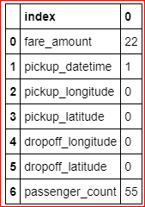

We will impute values for fare_amount and passenger_count as both of them has missing values 22 and 55 respectively. And we will drop that 1 row which has missing value in pickup_datetime.

Below are the missing value percentage for each variable:

Variables | Missing_percentage
0 | passenger_count | 0.351191
1 | fare_amount | 0.140476
2 | pickup_datetime | 0.006385
3 | pickup_longitude | 0.000000
4 | pickup_latitude | 0.000000
5 | dropoff_longitude | 0.000000
6 | dropoff_latitude | 0.000000

And below is the Standard deviation of particular variable which has missing values in them:
fare_amount: 435. 982171

passenger_count: 1.266096
dtype: float64

We applied central statistical methods and algorithmic method--KNN to impute missing values in the dataset:

- For Passenger_count:

Actual value = 1 Mode = 1

KNN = 2

We will not use Mode method because whole variable will be more biased towards 1 passenger_count, also passenger_count has maximum value equals to 1. So we will choose the KNN method here because it maintains the standard deviation of variable.

- For fare_amount:

Actual value = 7.0, Mean = 15.117, Median = 8.5, KNN = 7.369801

We will Choose KNN method here because it imputes value closest to actual value and also it maintains the Standard deviation of the variable.

Standard deviation for passenger_count and fare_amount after KNN imputation:

fare_amount: | 435.661995
passenger_count | 1.264322
dtype: float64

Outlier analysis using box plot:-

We look for outlier in the dataset by plotting Boxplots. There are outliers present in the data. we have removed these outliers. This is how we have done,

      - We replaced them with Nan values or we can say created missing values.
      - Then we imputed those missing values with KNN method.

        - We will do Outlier Analysis only on Fare_amount just for now and we will do outlier analysis after feature engineering laitudes and longitudes.

        - Univariate Boxplots: Boxplots for target variable.

Univariate Boxplots: Boxplots for all Numerical Variables also for target variable

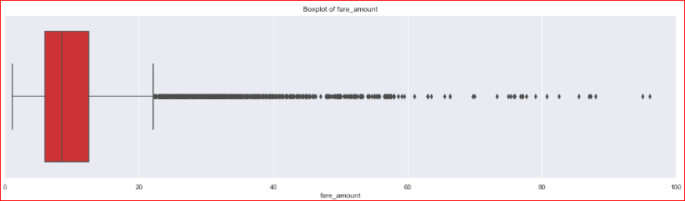

Bivariate Boxplots: Boxplots for all fare_amount Variables Vs all passenger_count variable.

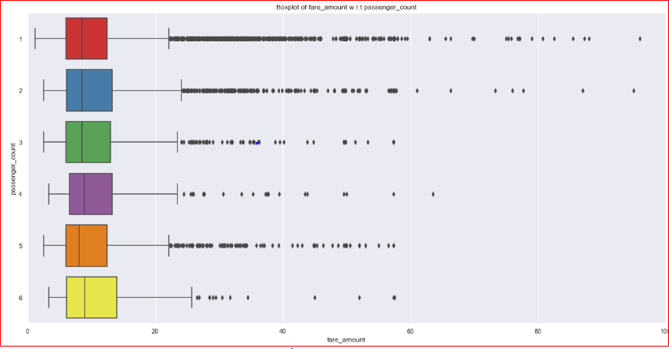

From above Boxplots we see that ‘fare_amount’ have outliers in it:

‘fare_amount’ has 1359 outliers.

We successfully imputed these outliers with KNN and K value is 3

    - Feature Engineering

Feature Engineering is used to derive new features from existing features.

      - Fo r ‘pickup _dat et ime’ vari abl e :

We will use this ‘pickup _dat et ime’ variable to create new variables. New features will be year, month, day_of_week, hour.
- ‘year’ will contain only years from pickup_datetime. For ex. 2009, 2010, 2011, etc.
- ‘month’ will contain only months from pickup_datetime. For ex. 1 for January, 2 for February,etc.
- ‘day_of_week’ will contain only week from pickup_datetime. For ex. 1 which is for Monday,2 for Tuesday,etc.
- ‘hour’ will contain only hours from pickup_datetime. For ex. 1, 2, 3, etc.

As we have these new variables we will categorize them to variables like Session from hour column, seasons from month column, week: weekday/weekend from day_of_week variable.

So, session variable will contain categories—morning, afternoon, evening, night_PM, night_AM.
Seasons variable will contain categories—spring, summer, fall, winter. Week will contain categories—weekday, weekend.

      - Fo r ‘Latitudes’ and ‘Longitudes’ var iab les :

As we have latitude and longitude data for pickup and dropoff, we will find the distance the cab travelled from pickup and dropoff location.

We will use both haversine and vincenty methods to calculate distance.

For haversine, variable name will be ‘great_circle’ and for vincenty, new variable name will be ‘geodesic’.

As vincenty is more accurate than haversine. Also, vincenty is prefered for short distances. Therefore, we will drop great_circle(haversine).

Columns in training data after feature engineering: Index(['fare_amount', 'passenger_count_2', 'passenger_count_3',
'passenger_count_4', 'passenger_count_5', 'passenger_count_6', 'season_spring', 'season_summer', 'season_winter', 'week_weekend', 'session_evening', 'session_morning', 'session_night_AM', 'session_night_PM', 'year_2010', 'year_2011', 'year_2012', 'year_2013', 'year_2014', 'year_2015', 'geodesic'],
dtype='object')

Columns in testing data after feature engineering: Index(['passenger_count_2', 'passenger_count_3', 'passenger_count_4',
'passenger_count_5', 'passenger_count_6', 'season_spring', 'season_summer', 'season_winter', 'week_weekend', 'session_evening', 'session_morning', 'session_night_AM', 'session_night_PM', 'year_2010', 'year_2011', 'year_2012', 'year_2013', 'year_2014', 'year_2015', 'geodesic'],
dtype='object')

we will plot boxplot for our new variable ‘geodesic’:

We see that there are outliers in ‘geodesic’ and also a cab cannot go upto 3400 miles

Boxplot of ‘geodesic’ for range 0 to 100 miles.

We will treat these outliers like we previously did , i.e. by imputing the values using KNN.

    - Feature Selection

In this step we would allow only to pass relevant features for further steps. We will remove irrelevant features from the dataset. We will do this by some statistical techniques, like we look for features which will not be helpful in predicting the target variables. In this dataset we have to predict the ‘fare_amount’.

Further below are some types of test involved for feature selection:

- Correlation analysis – This requires only numerical variables. Therefore, we will filter out only numerical variables and feed it for correlation analysis. We do this by plotting correlation plot for all numerical variables. There should be no correlation between independent variables but there should be high correlation between independent variable and dependent variable. So, we plot the correlation plot. we can see that in correlation plot faded colour like skin colour indicates that 2 variables are highly correlated with each other. As the colour fades correlation values increases.
From below correlation plot we see that:
      - 'fare_amount' and 'geodesic' are very highly correlated with each other.
      - As fare_amount is the target variable and ‘geodesic’ is independent variable we will keep ‘geodesic’ because it will help to explain variation in fare_amount.

Correlation Plot:

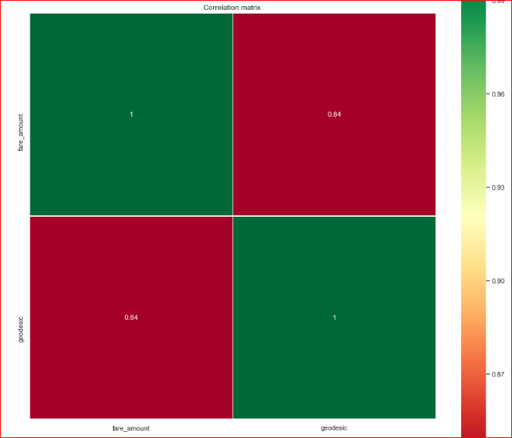

Jointplot between ‘geodesic’ and ‘fare_amount’:

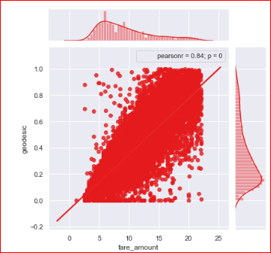

2. Chi-Square test of independence –
Unlike correlation analysis we will filter out only categorical variables and pass it to Chi-Square test. Chi-square test compares 2 categorical variables in a contingency table to see if they are related or not.

- Assumption for chi-square test: Dependency between Independent variable and dependent variable should be high and there should be no dependency among independent variables.
- Before proceeding to calculate chi-square statistic, we do the hypothesis testing: Null hypothesis: 2 variables are independent.
Alternate hypothesis: 2 variables are not independent.

The interpretation of chi-square test:
  - For theorical or excel sheet purpose: If chi-square statistics is greater than critical value then reject the null hypothesis saying that 2 variables are dependent and if it’s less, then accept the null hypothesis saying that 2 variables are independent.
  - While programming: If p-value is less than 0.05 then we reject the null hypothesis saying that 2 variables are dependent and if p-value is greater than 0.05 then we accept the null hypothesis saying that 2 variables are independent.

Here we did the test between categorical independent variables pairwise.
- If p-value<0.05 ,then remove the variable,

- If p-value>0.05 ,then keep the variable.

Analysis of Variance(ANOVA) Test –
- It is carried out to compare between each group in a categorical variable.
- ANOVA only lets us know the means of different groups are same or not. It
doesn’t help us identify which mean is different.

Hypothesis testing:
Null Hypothesis: mean of all categories in a variable are same.
Alternate Hypothesis: mean of at least one category in a variable is different.

- If p-value is less than 0.05 then we reject the null hypothesis.
- And if p-value is greater than 0.05 then we accept the null hypothesis.

Below is the ANOVA analysis table for each categorical variable:
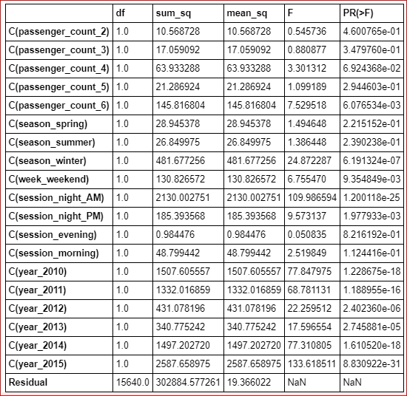

Looking at above table every variable has p value less than 0.05 so rejecting the null hypothesis.

4 Multicollinearity– In regression, "multicollinearity" refers to predictors that are correlated with other predictors. Multicollinearity occurs when your model includes

multiple factors that are correlated not just to your response variable, but also to each other.

- Multicollinearity increases the standard errors of the coefficients.
- Increased standard errors in turn means that coefficients for some independent variables may be found not to be significantly different from 0.
- In other words, by overinflating the standard errors, multicollinearity makes some variables statistically insignificant when they should be significant.
- Without multicollinearity (and thus, with lower standard errors), those coefficients might be significant.
- VIF is always greater or equal to 1.
if VIF is 1 --- Not correlated to any of the variables. if VIF is between 1-5 --- Moderately correlated.
if VIF is above 5 --- Highly correlated.
If there are multiple variables with VIF greater than 5, only remove the variable with the highest VIF.

Below is the table for VIF analysis for each independent variable:
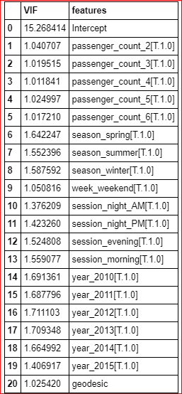

We have checked for multicollinearity in our Dataset and all VIF values are below 5. So we have no or very low multicollinearity.

    - Feature Scaling

Data Scaling methods are used when we want our variables in data to be scaled on common ground. It is performed only on continuous variables.

      - Normalization: Normalization refers to dividing of a vector by its length. Normalization normalizes the data in the range of 0 to 1. It is generally used when we are planning to use distance method for our model development purpose such as KNN. Normalizing the data improves convergence of such algorithms. Normalisation of data scales the data to a very small interval, where outliers can be reduced.

      - Standardization: Standardization refers to the subtraction of mean from individual point and then dividing by its Standard deviation. Z is negative when the raw score is below the mean and Z is positive when above mean. When the data is distributed normally we go for standardization.

Also, our independent numerical variable ‘geodesic’ is not distributed normally so we have chosen normalization over standardization.

- We have checked variance for each column in dataset before Normalisation
- High variance will affect the accuracy of the model. So, we will normalise that variance.

Note: It is performed only on Continuous variables.

distplot() for ‘geodesic’ feature before normalization:

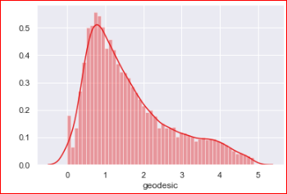

qq probability plot before normalization:

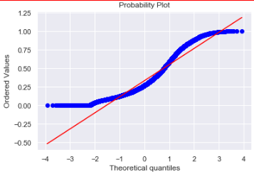

distplot() for ‘geodesic’ feature after normalization
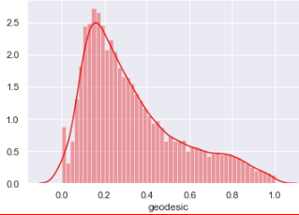

qq probability plot after normalization:

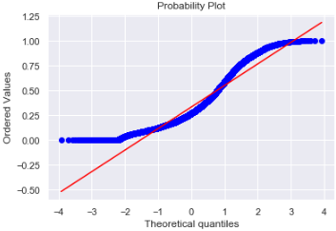

Chapter 3

Splitting train and Validation Dataset

- We have used sklearn’s train_test_split() method to divide whole dataset into train and validation dataset.
- 25% is in validation dataset and 75% is in training dataset.
- 11745 observations in training and 3915 observations in validation dataset.
- We will test the performance of model on validation dataset.
- The model which performs best will be chosen to perform on test dataset provided along with original train dataset.
- X_train y_train--are train subset.
- X_test y_test--are validation subset.

Chapter 4

Hyperparameter Optimization

- To find the optimal hyperparameter we have used sklearn.model_selection.GridSearchCV.
- GridSearchCV tries all the parameters that we provide it and then returns the best suited parameter for data.
- We gave parameter dictionary to GridSearchCV which contains keys which are parameter names and values are the values of parameters which we want to try for.
Below are best hyperparameter we found for different models:
  - Multiple Linear Regression:
Tuned Decision reg Parameters: {'copy_X': True, 'fit_intercept': True} Best score is 0.7354470072210966

  - Decision Tree Regression:
Tuned Decision Tree Parameters: {'max_depth': 6, 'min_samples_split': 2} Best score is 0.7313489270203365

  - Random Forest Regression:
Tuned Decision Forest Parameters: {'n_estimators': 100, 'min_samples_split': 2, 'min_samples_leaf': 4, 'max_features': 'auto', 'max_depth': 9, 'bootstrap': True}
Best score is 0.7449373558797026

VI. Xgboost regression:
Tuned Xgboost Parameters: {'subsample': 0.1, 'reg_alpha': 0.08685113737513521, 'n_estimators': 200, 'max_depth': 3, 'learning_rate':
0.05, 'colsample_bytree': 0.7000000000000001, 'colsample_bynode':
0.7000000000000001, 'colsample_by level': 0.9000000000000001}
Best score is 0.7489532917329004

Chapter 5

Model Development
Our problem statement wants us to predict the fare_amount. This is a Regression problem. So, we are going to build regression models on training data and predict it on test data. In this project I have built models using 4 Regression Algorithms:
- Linear Regression
- Decision Tree
- Random Forest
- Xgboost Regression

We will evaluate performance on validation dataset which was generated using Sampling. We will deal with specific error metrics like –
Regression metrics for our Models:
- r square
- Adjusted r square
- MAPE (Mean Absolute Percentage Error)
- MSE (Mean square Error)
- RMSE (Root Mean Square Error)
- RMSLE ( Root Mean Squared Log Error)

    - Model Performance

Here, we will evaluate the performance of different Regression models based on different Error Metrics

      - Multiple Linear Regression:

Error Metrics | r square | Adj r sq | MAPE | MSE | RMSE | RMSLE
Train | 0.734 | 0.733 | 18.73 | 5.28 | 2.29 | 0.21
Validation | 0.719 | 0.7406 | 18.96 | 5.29 | 2.30 | 0.21

Line Plot for Coefficients of Multiple Linear regression:

II. Decision Tree Regression:

Bar Plot of Decision tree Feature Importance:

Error Metrics | r square | Adj r sq | MAPE | MSE | RMSE | RMSLE
Train | 0.7471 | 0.7467 | 18.54 | 5.02 | 2.24 | 0.20
Validation | 0.7408 | 0.7396 | 19.07 | 5.31 | 2.30 | 0.21

- Random Forest Regression:

Error Metrics | r square | Adj r sq | MAPE | MSE | RMSE | RMSLE
Train | 0.7893 | 0.7889 | 16.95 | 4.19 | 2.04 | 0.19
Validation | 0.7542 | 0.7530 | 18.56 | 5.09 | 2.24 | 0.20

Bar Plot of Random Forest Feature Importance:

Chapter 6
Improving accuracy
- Improve Accuracy a) Algorithm Tuning b) Ensembles
- We have used Xgboost as an ensemble technique.

Xgboost hyperparameters tuned parameters:Tuned Xgboost Parameters: {'subsample': 0.1, 'reg_alpha': 0.08685113737513521, 'n_estimators': 200, 'max_depth': 3, 'learning_rate': 0.05,
'colsample_bytree': 0.7000000000000001, 'colsample_bynode': 0.7000000000000001,
'colsample_bylevel': 0.9000000000000001}

Error Metrics | r square | Adj r sq | MAPE | MSE | RMSE | RMSLE
Train | 0.7542 | 0.7538 | 18.15 | 4.88 | 2.21 | 0.20
Validation | 0.7587 | 0.7575 | 18.37 | 4.96 | 2.22 | 0.20

Xgboost Regression:

Bar Plot of Xgboost Feature Importance:

Chapter 7
Finalize model
- Create standalone model on entire training dataset
- Save model for later use

We have trained a Xgboost model on entire training dataset and used that model to predict on test data. Also, we have saved model for later use.
<<<------------------- Training Data Score --------------------->

r square 0.7564292952182666
Adjusted r square: 0.7561333973032505
MAPE: 18.100202501103993
MSE: 4.881882644209386
RMSE: 2.2094982788428204
RMSLE: 0.2154998534679604
RMSLE: 0.20415655796958632

Feature importance:

Python-Code

In [1]:# loading the required libraries
import os
import pandas as pd
import numpy as np
import matplotlib.pyplot as plt
import seaborn as sns
import scipy.stats as stats
from fancyimpute import KNN
from geopy.distance import geodesic
from geopy.distance import great_circle
from scipy.stats import chi2_contingency
import statsmodels.api as sm
from statsmodels.formula.api import ols
from patsy import dmatrices
from statsmodels.stats.outliers_influence import variance_inflation_factor
from sklearn.model_selection import train_test_split
from sklearn.metrics import mean_squared_error
from sklearn import metrics
from sklearn.linear_model import Linear Regression
from sklearn.model_selection import GridSearchCV
from sklearn.model_selection import RandomizedSearchCV
from sklearn.model_selection import cross_val_score
from sklearn.ensemble import RandomForest Regressor
from sklearn.tree import DecisionTree Regressor
from xgboost import XGB Regressor
import xgboost as xgb
from sklearn.externals import joblib

In [2]: # set the working directory
os.chdir('C:/Users/user/Python3')
os.getcwd()
Out[2]: ‘C:/Users/user/Python3’

Predictive modeling machine learning project can be broken down into below workflow:
- Prepare Problem a) Load libraries b) Load dataset
- Summarize Data a) Descriptive statistics b) Data visualizations
- Prepare Data a) Data Cleaning b) Feature Selection c) Data Transforms
- Evaluate Algorithms a) Split-out validation dataset b) Test options and evaluation metric c) Spot Check Algorithms d) Compare Algorithms
- Improve Accuracy a) Algorithm Tuning b) Ensembles
- Finalize Model a) Predictions on validation dataset b) Create standalone model on entire training dataset c) Save model for later use

In [3]:# Importing data
train = pd.read_csv('train_cab.csv',dtype={'fare_amount':np.float64},na_values={'fare_amount':'430-'})
test = pd.read_csv('test.csv')
data=[train,test]
for i in data:i['pickup_datetime'] = pd.to_datetime(i['pickup_datetime'],errors='coerce')
train.head(5)
Out[3]:
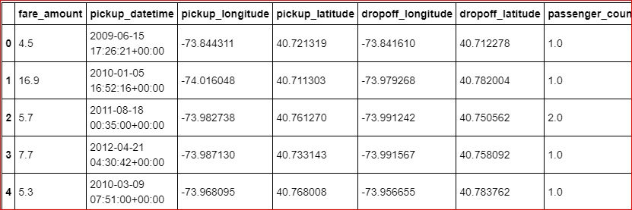

In [4]:train.info()
<class 'pandas.core.frame.DataFrame'>
RangeIndex: 16067 entries, 0 to 16066
Data columns (total 7 columns):
fare_amount 16042 non-null float64
pickup_datetime 16066 non-null datetime64[ns, UTC]
pickup_longitude 16067 non-null float64
pickup_latitude 16067 non-null float64
dropoff_longitude 16067 non-null float64
dropoff_latitude 16067 non-null float64
passenger_count 16012 non-null float64
dtypes: datetime64[ns, UTC](1), float64(6)
memory usage: 878.7 KB

In [6]:test.head(5)
Out[6]: 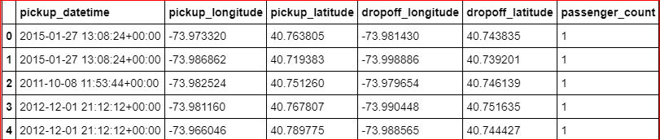

In [7]:test.info()
<class 'pandas.core.frame.DataFrame'>
RangeIndex: 9914 entries, 0 to 9913
Data columns (total 6 columns):
pickup_datetime 9914 non-null datetime64[ns, UTC]
pickup_longitude 9914 non-null float64
pickup_latitude 9914 non-null float64
dropoff_longitude 9914 non-null float64
dropoff_latitude 9914 non-null float64
passenger_count 9914 non-null int64
dtypes: datetime64[ns, UTC](1), float64(4), int64(1)
memory usage: 464.8 KB

EDA
- we will convert passenger_count into a categorical variable because passenger_count is not a continuous variable.
- passenger_count cannot take continuous values. and also they are limited in number if its a cab.

In [73]:cat_var=['passenger_count']num_var=['fare_amount','pickup_longitude','pickup_latitude','dropoff_longitude','dropoff_latitude']

Graphical EDA - Data Visualization

In [38]:# setting up the sns for plots
sns.set(style='darkgrid',palette='Set1')

Some histogram plots from seaborn library

In [75]:plt.figure(figsize=(20,20)
plt.subplot(321)_ = sns.distplot(train['fare_amount'],bins=50)
plt.subplot(322)_ = sns.distplot(train['pickup_longitude'],bins=50)
plt.subplot(323)_ = sns.distplot(train['pickup_latitude'],bins=50)
plt.subplot(324)_ = sns.distplot(train['dropoff_longitude'],bins=50)
plt.subplot(325)_ = sns.distplot(train['dropoff_latitude'],bins=50)
# plt.savefig('hist.png')
plt.show()

- Jointplots for Bivariate Analysis.
- Here Scatter plot has regression line between 2 variables along with separate Bar plots of both variables.
- Also its annotated with pearson correlation coefficient and p value.

In [76]: _ = sns.jointplot(x='fare_amount',y='pickup_longitude',data=train,kind = 'reg')_.annotate(stats.pearsonr)
# plt.savefig('jointfplo.png')
plt.show()

In [77]:_ = sns.jointplot(x='fare_amount',y='pickup_latitude',data=train,kind = 'reg')
_.annotate(stats.pearsonr)
# plt.savefig('jointfpla.png')

plt.show()

In [78]: _ = sns.jointplot(x='fare_amount',y='dropoff_longitude',data=train,kind = 'reg')_.annotate(stats.pearsonr)
# plt.savefig('jointfdlo.png')
plt.show()

In [79]:_ = sns.jointplot(x='fare_amount',y='dropoff_latitude',data=train,kind = 'reg')
_.annotate(stats.pearsonr)
# plt.savefig('jointfdla.png')
plt.show()

Pairwise plots for all numerical variables
In [81]: _ =sns.pairplot(data=train[num_var],kind='scatter',dropna=True)
_.fig.suptitle('Pairwise plot of all numerical variables')
# plt.savefig('Pairwise.png')
plt.show()

Removing values which are not within desired range(outliers) depending upon basic understanding of dataset.

- Fare amount has a negative value, which doesn't make sense. A price amount cannot be -ve and also cannot be 0. So we will remove these fields.

In [23]: sum(train['fare_amount']<1)
Out[23]: 5

In [24]: train[train['fare_amount']<1]

Out[24]: 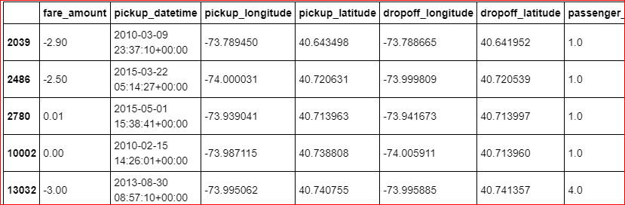

In [4]: train = train.drop(train[train['fare_amount']<1].index, axis=0)

2. Passenger count cannot be <1 or >6. Removing the outliers

In [79]: for i in range(4,11):
print('passenger_count above' +str(i)+'={}'.format(sum(train['passenger_count']>i)))

passenger_count above4=1367
passenger_count above5=322
passenger_count above6=20
passenger_count above7=20
passenger_count above8=20
passenger_count above9=20
passenger_count above10=20

So, 20 observations of passenger_count is consistenly above from 6,7,8,9,10 passenger_counts, let's check them.

In [5]: train = train.drop(train[train['passenger_count']>6].index, axis=0)
train = train.drop(train[train['passenger_count']<1].index, axis=0)

In [89]: sum(train['passenger_count']>6)
Out[89]: 0

3. Latitudes range from -90 to 90.Longitudes range from -180 to 180. Removing which does not satisfy these ranges

In [10]:
print ('pickup_longitude above 180={}'.format(sum(train['pickup_longitude']>180)))
print('pickup_longitude below -180={}'.format(sum(train['pickup_longitude']<-180)))
print('pickup_latitude above 90={}'.format(sum(train['pickup_latitude']>90)))
print('pickup_latitude below -90={}'.format(sum(train['pickup_latitude']<-90)))
print('dropoff_longitude above 180={}'.format(sum(train['dropoff_longitude']>180)))
print('dropoff_longitude below -180={}'.format(sum(train['dropoff_longitude']<-180)))
print('dropoff_latitude below -90={}'.format(sum(train['dropoff_latitude']<-90)))
print('dropoff_latitude above 90={}'.format(sum(train['dropoff_latitude']>90)))
pickup_longitude above 180=0
pickup_longitude below -180=0
pickup_latitude above 90=1
pickup_latitude below -90=0
dropoff_longitude above 180=0
dropoff_longitude below -180=0
dropoff_latitude below -90=0
dropoff_latitude above 90=0

- There's only one outlier which is in variable pickup_latitude. So we will remove it with nan.
- Also we will see if there are any values equal to 0.

In [11]:
for i in ['pickup_longitude','pickup_latitude','dropoff_longitude','dropoff_latitude']:
print(i,'equal to 0={}'.format(sum(train[i]==0)))

pickup_longitude equal to 0=315
pickup_latitude equal to 0=315
dropoff_longitude equal to 0=314
dropoff_latitude equal to 0=312

These are values which are equal to 0. We will remove them.

In [6]: train = train.drop(train[train['pickup_latitude']>90].index, axis=0)
for i in ['pickup_longitude','pickup_latitude','dropoff_longitude','dropoff_latitude']:
train = train.drop(train[train[i]==0].index, axis=0)

In [7]: train.shape
Out[7]: (15661, 7)

Outlier Analysis using Boxplot
- We will do Outlier Analysis only on Fare_amount just for now and we will do outlier analysis after feature engineering latitudes and longitudes.
- Univariate Boxplots: Boxplots for all Numerical Variables including target variable.

In [41]: plt.figure (figsize=(20,5))
plt.xlim(0,100)
sns.boxplot(x=train['fare_amount'],data=train, orient='h')
plt.title('Boxplot of fare_amount')
# plt.savefig('bp of fare_amount.png')
plt.show()

In [42]:
plt.figure (figsize=(20,10))
plt.xlim (0,100) = sns.boxplot(x=train['fare_amount'], y=train['passenger_count'], data= train, orient='h')
plt.title('Boxplot of fare_amount w.r.t passenger_count')
# plt.savefig('Boxplot of fare_amount w.r.t passenger_count.png')
plt.show()

In [43]:
train.describe()
Out[43]:
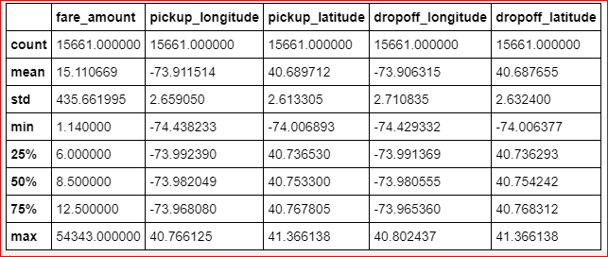

In [44]:
train['passenger_count'].describe()
Out[44]:
count 15661
unique 6
top 1
freq 11056
Name: passenger_count, dtype: int64

Outlier Treatment
- As we can see from the above Boxplots there are outliers in the train dataset.
- Reconsider pickup_longitude, etc.

In [51]:
def outlier_treatment(col):
''' calculating outlier indices and replacing them with NA '''
#Extract quartiles
q75, q25 = np.percentile(train[col], [75 ,25])
print(q75,q25)
#Calculate IQR
iqr = q75 - q25
#Calculate inner and outer fence
minimum = q25 - (iqr*1.5)
maximum = q75 + (iqr*1.5)
print(minimum,maximum)
#Replace with NA
train.loc[train[col] < minimum,col] = np.nan
train.loc[train[col] > maximum,col] = np.nan

In [52]:
# for i in num_var:
outlier_treatment('fare_amount')
# outlier_treatment('pickup_longitude')
# outlier_treatment('pickup_latitude')
# outlier_treatment('dropoff_longitude')
# outlier_treatment('dropoff_latitude')
12.5 6.0
-3.75 22.25

In [53]: pd.DataFrame(train.isnull().sum())
Out[53]:
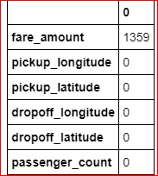

In [54]: train.std()
Out[54]:
fare_amount 4.136102
pickup_longitude 2.659050
pickup_latitude 2.613305
dropoff_longitude 2.710835
dropoff_latitude 2.632400
passenger_count 1.264322
dtype: float64

In [55]:#Imputing with missing values using KNN
train = pd.DataFrame(KNN(k = 3).fit_transform(train), columns = train.columns, index=train.index)

In [56]: train.std()
Out[56]:
fare_amount 4.476970
pickup_longitude 2.659050
pickup_latitude 2.613305
dropoff_longitude 2.710835
dropoff_latitude 2.632400
passenger_count 1.264322
dtype: float64

In [57]:
train['passenger_count'].describe()
Out[57]:
count 15661.000000
mean 1.649192
std 1.264322
min 1.000000
25% 1.000000
50% 1.000000
75% 2.000000
max 6.000000
Name: passenger_count, dtype: float64

In [58]:
train['passenger_count']=train['passenger_count'].astype('int').round().astype('object').astype('category')

In [59]: train.describe()
Out[59]:
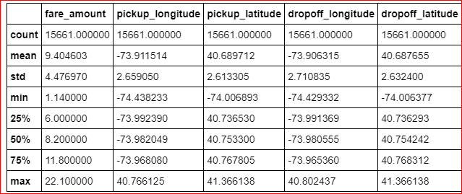

In [60]: train.head()
Out[60]:
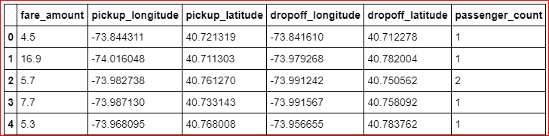

In [61]:
df2 = train.copy()
# train= df2.copy()
In [62]: train.shape
Out[62]: (15661, 6)

Missing Value Analysis

In [8]: #Create dataframe with missing percentage
missing_val = pd.DataFrame(train.isnull().sum())
#Reset index
missing_val = missing_val.reset_index()missing_val

Out[8]:

- As we can see there are some missing values in the data.
- We will impute missing values for fare_amount, passenger_count variables except pickup_datetime.
- And we will drop that 1 row which has missing value in pickup_datetime.

In [9]: #Rename variable
missing_val = missing_val.rename(columns = {'index': 'Variables', 0: 'Missing_percentage'})missing_val
#Calculate percentage
missing_val['Missing_percentage'] = (missing_val['Missing_percentage']/len(train))*100
#descending order
missing_val = missing_val.sort_values('Missing_percentage',ascending = False).reset_index(drop = True)missing_val
Out[9]:
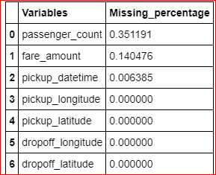

  - For Passenger_count:
- Actual value = 1
- Mode = 1
- KNN = 2

In [13]: # Choosing a random values to replace it as NA
train['passenger_count'].loc[1000]
Out[13]: 1.0
In [14]:# Replacing 1.0 with NA
train['passenger_count'].loc[1000] = np.nan
train['passenger_count'].loc[1000]
Out[14]: nan

In [15]:# Impute with mode
train['passenger_count'].fillna(train['passenger_count'].mode()[0]).loc[1000]
Out[15]:1.0

  - For fare_amount:
- Actual value = 7.0,
- Mean = 15.117,
- Median = 8.5,
- KNN = 7.369801

In [16]: # Choosing a random values to replace it as NA
a=train['fare_amount'].loc[1000]
print('fare_amount at loc-1000:{}'.format(a))
# Replacing 7.0 with NA
train['fare_amount'].loc[1000] = np.nan
print('Value after replacing with nan:{}'.format(train['fare_amount'].loc[1000]))
# Impute with mean
print('Value if imputed with mean:{}'.format(train['fare_amount'].fillna(train['fare_amount'].mean()).loc[1000]))
# Impute with median
print('Value if imputed with median:{}'.format(train['fare_amount'].fillna(train['fare_amount'].median()).loc[1000]))
Fare_amount at loc-1000: 7.0
Value after replacing with nan: nan
Value if imputed with mean: 15.118196060877201
Value if imputed with median: 8.5

In [17]: train.std()
Out[17]:
fare_amount 435.982171
pickup_longitude 2.659050
pickup_latitude 2.613305
dropoff_longitude 2.710835
dropoff_latitude 2.632400
passenger_count 1.266096
dtype: float64

In [18]: columns=['fare_amount', 'pickup_longitude', 'pickup_latitude','dropoff_longitude', 'dropoff_latitude', 'passenger_count']

we will separate pickup_datetime into a different dataframe and then merge with train in feature engineering step.

In [19]: pickup_datetime= pd.DataFrame(train['pickup_datetime'])

In [20]: # Imputing with missing values using KNN
train = pd.DataFrame(KNN(k = 19).fit_transform(train.drop('pickup_datetime',axis=1),columns=columns, index= train.index)
In [21]: train.std()
Out[21]:
fare_amount 435.661995
pickup_longitude 2.659050
pickup_latitude 2.613305
dropoff_longitude 2.710835
dropoff_latitude 2.632400
passenger_count 1.264138
dtype: float64

In [23]:
train['passenger_count'].head(5)
Out[23]:
0 1.0
1 1.0
2 2.0
3 1.0
4 1.0
Name: passenger_count, dtype: float64

In [24]:
train['passenger_count']=train['passenger_count'].astype('int')

In [26]:
train['passenger_count'].unique()
Out[26]:
array([1, 2, 3, 6, 5, 4], dtype=int64)

In [27]:
train['passenger_count']= train['passenger_count'].round().astype('object').astype('category',ordered=True)
In [28]:
train['passenger_count'].unique()
Out[28]:
[1, 2, 3, 6, 5, 4]
Categories (6, int64): [1 < 2 < 3 < 4 < 5 < 6]

In [29]: train.loc[1000]
Out[29]:
fare_amount 7.3698
pickup_longitude -73.9954
pickup_latitude 40.7597
dropoff_longitude -73.9876
dropoff_latitude 40.7512
passenger_count 2
Name: 1000, dtype: object

  - Now about missing value in pickup_datetime

In [30]: pickup_datetime.head()
Out[30]:
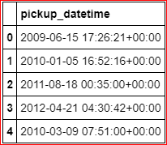

In [31]:#Create dataframe with missing percentage
missing_val = pd.DataFrame(pickup_datetime.isnull().sum())
#Reset index
missing_val = missing_val.reset_index()missing_val
Out[31]:
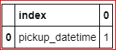

In [32]: pickup_datetime.shape
Out[32]: (15661, 1)

In [33]: train.shape
Out[33]: (15661, 6)

- We will drop 1 row which has missing value for pickup_datetime variable after feature engineering step because if we drop now, pickup_datetime dataframe will have 16040 rows and our train has 16041 rows, then if we merge these 2 dataframes then pickup_datetime variable will gain 1 missing value.
- And if we merge and then drop now then we would require to split again and then merge again in feature engineering step.
- So, instead of doing the work 2 times we will drop 1 time i.e. after feature engineering process.

In [36]: train.describe()
Out[36]:
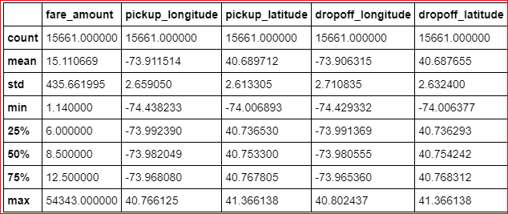

Feature Engineering

1. Feature Engineering for (pickup_datetime ) timestamp variable

- we will derive new features from pickup_datetime variable
- new features will be year, month, day_of_week, hour

In [63]: # we will Join 2 Dataframes pickup_datetime and train
train = pd.merge(pickup_datetime,train,right_index=True, left_index=True)
train.head(5)
Out[63]:
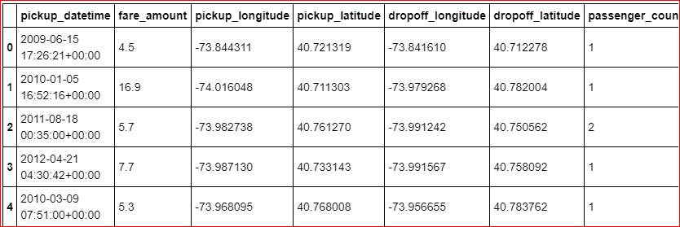

In [64]: train.shape
Out[64]: (15661, 7)

In [65]: train=train.reset_index(drop=True)

As we discussed in Missing value imputation step about dropping missing value, we will do it now.

In [66]: pd.DataFrame(train.isna().sum())
Out[66]:
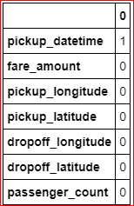

In [67]: train= train.dropna()
In [68]:data = [train,test]
for i in data:
i["year"] = i["pickup_datetime"].apply(lambda row: row.year)
i["month"] = i["pickup_datetime"].apply(lambda row: row.month)
#i["day_of_month"] = i["pickup_datetime"].apply(lambda row: row.day)
i["day_of_week"] = i["pickup_datetime"].apply(lambda row: row.dayofweek)
i["hour"] = i["pickup_datetime"].apply(lambda row: row.hour)

In [72]: plt.figure(figsize=(20,10))
sns.countplot(train['year'])
# plt.savefig('year.png')

plt.figure(figsize=(20,10))
sns.countplot(train['month'])
# plt.savefig('month.png')

plt.figure(figsize=(20,10))
sns.countplot(train['day_of_week'])
# plt.savefig('day_of_week.png')

plt.figure(figsize=(20,10))
sns.countplot(train['hour'])
# plt.savefig('hour.png'
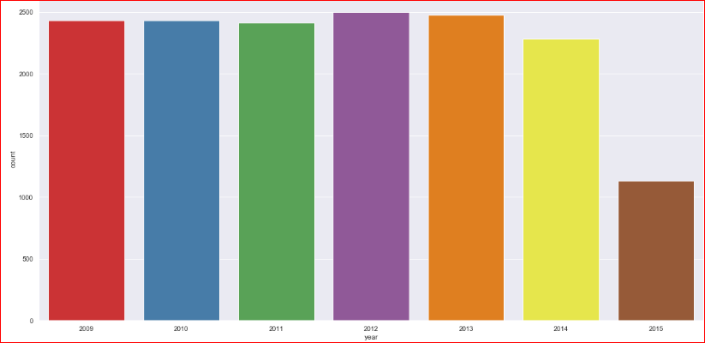
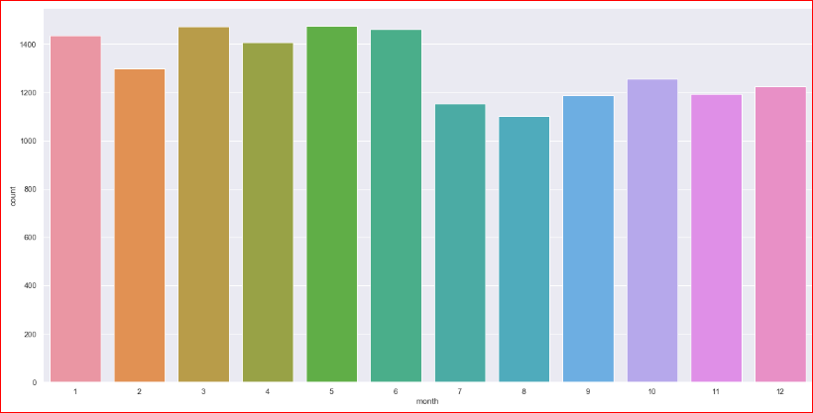

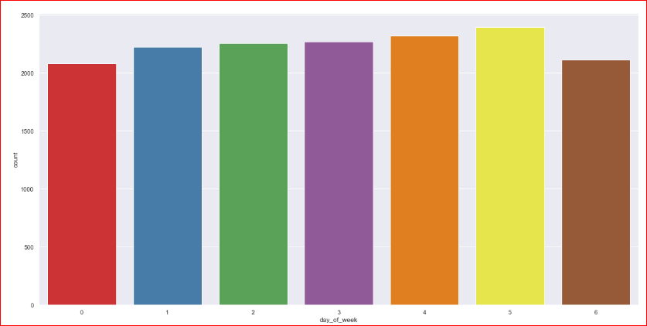
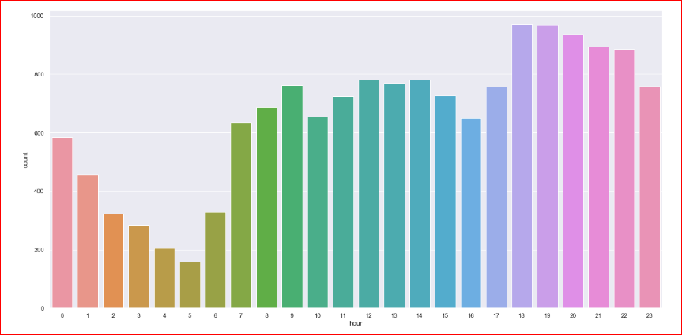

Now we will use month, day_of_week, hour to derive new features like sessions in a day, seasons in a year, week: weekend/weekday.

In [73]: def f(x):
''' for sessions in a day using hour column '''
if (x >=5) and (x <= 11):
return 'morning'
else if (x >=12) and (x <=16 ):
return 'afternoon'
else if (x >= 17) and (x <= 20):
return 'evening'
else if (x >=21) and (x <= 23) :
return 'night_PM'
else if (x >=0) and (x <=4):
return 'night_AM'
In [74]: def g(x):
''' for seasons in a year using month column'''
if (x >=3) and (x <= 5):
return 'spring'
else if (x >=6) and (x <=8 ):
return 'summer'
else if (x >= 9) and (x <= 11):
return 'fall'
else if (x >=12)|(x <= 2) :
return 'winter'

In [75]: def h(x):
''' for week:weekday/weekend in a day_of_week column '''
if (x >=0) and (x <= 4):
return 'weekday'
else if (x >=5) and (x <=6 ):
return 'weekend'

In [76]: train['session'] = train['hour'].apply(f)
test['session'] = test['hour'].apply(f)

In [77]:
train['seasons'] = train['month'].apply(g)
test['seasons'] = test['month'].apply(g)

In [78]:
train['week'] = train['day_of_week'].apply(h)
test['week'] = test['day_of_week'].apply(h)

In [79]: train.shape
Out[79]: (15660, 14)

In [80]: test. shape
Out[80]: (9914, 13)

3. Feature Engineering for latitude and longitude variable

- As we have latitude and longitude data for pickup and dropoff, we will find the distance the cab travelled from pickup and drop-off location.

In [91]:# Calculate distance the cab travelled from pickup and dropoff location using great_circle and geodesic from geopy library
data = [train, test]
for i in data:
i['great_circle']=i.apply(lambda x: great_circle((x['pickup_latitude'],x['pickup_longitude']), (x['dropoff_latitude'], x['dropoff_longitude'])).miles, axis=1)
i['geodesic']=i.apply(lambda x: geodesic((x['pickup_latitude'],x['pickup_longitude']), (x['dropoff_latitude'], x['dropoff_longitude'])).miles, axis=1)

In [92]: train.head(5)
Out[92]: 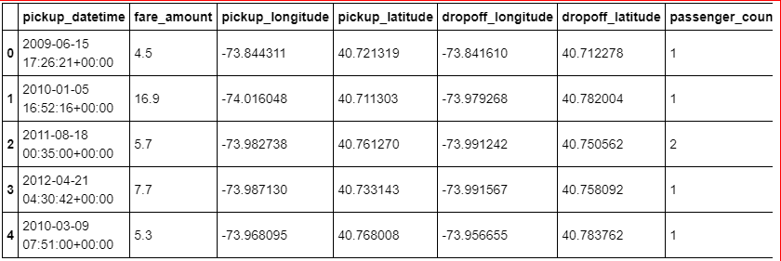5 rows × 35 columns

In [93]: test.head()
Out[93]:
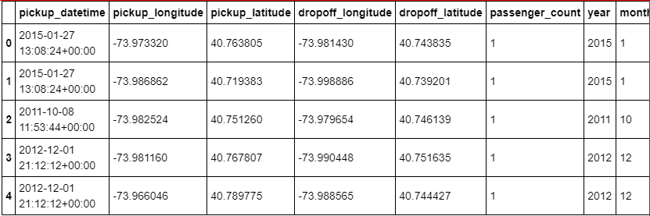5 rows × 34 columns

As Vincenty is more accurate than haversine. Also vincenty is prefered for short distances. Therefore we will drop great_circle. we will drop them together with other variables which were used for feature engineering.

In [94]: pd.DataFrame(train.isna().sum())

In [95]: pd.DataFrame(test.isna().sum())

We will remove the variables which were used to feature engineer new variables

In [96]: train=train.drop (['pickup_datetime','pickup_longitude', 'pickup_latitude',
'dropoff_longitude', 'dropoff_latitude', 'passenger_count', 'year',
'month', 'day_of_week', 'hour', 'session', 'seasons', 'week','great_circle'],axis=1)
test=test.drop(['pickup_datetime','pickup_longitude', 'pickup_latitude',
'dropoff_longitude', 'dropoff_latitude', 'passenger_count', 'year',
'month', 'day_of_week', 'hour', 'session', 'seasons', 'week','great_circle'],axis=1)

In [97] train.shape, test.shape
Out[97]: ((15660, 21), (9914, 20))

In [98]: train.columns
Out[98]:
Index(['fare_amount', 'passenger_count_2', 'passenger_count_3',
'passenger_count_4', 'passenger_count_5', 'passenger_count_6',
'season_spring', 'season_summer', 'season_winter', 'week_weekend',
'session_evening', 'session_morning', 'session_night_AM',
'session_night_PM', 'year_2010', 'year_2011', 'year_2012', 'year_2013',
'year_2014', 'year_2015', 'geodesic'],
dtype='object')

In [99]: test.columns
Out[99]:
Index(['passenger_count_2', 'passenger_count_3', 'passenger_count_4',
'passenger_count_5', 'passenger_count_6', 'season_spring',
'season_summer', 'season_winter', 'week_weekend', 'session_evening',
'session_morning', 'session_night_AM', 'session_night_PM', 'year_2010',
'year_2011', 'year_2012', 'year_2013', 'year_2014', 'year_2015',
'geodesic'],
dtype='object')

In [100]: train.head()
Out[100]:
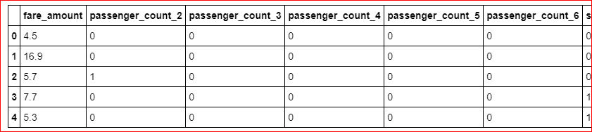
5 rows × 21 columns

In [101]: test.head()
Out[101]:
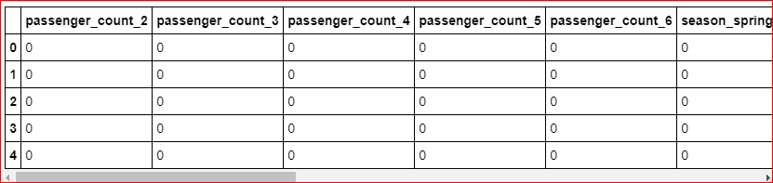

In [102]: plt.figure (figsize=(20,5))
sns.boxplot(x=train['geodesic'],data=train, orient='h')
plt.title ('Boxplot of geodesic ')
plt.show()
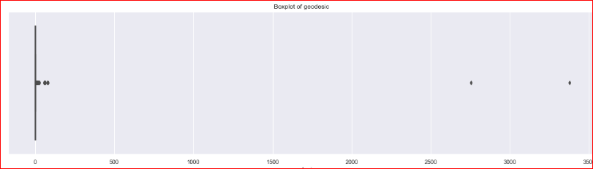

In [105]: plt.figure(figsize=(20,5))
plt.xlim(0,100)
sns.boxplot(x=train['geodesic'],data=train, orient='h')
plt.title('Boxplot of geodesic ')
plt.show()
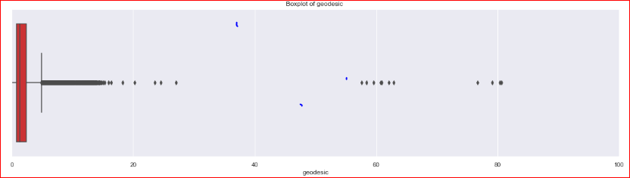

In [107]: outlier_treatment('geodesic')
2.425668049965582 0.7815214474966259
-1.6846984562068081 4.891887953669016

In [108]: pd.DataFrame(train.isnull().sum())

In [109]: #Imputing with missing values using KNN
train = pd.DataFrame(KNN(k = 3).fit_transform(train), columns = train.columns, index=train.index)

Feature Selection
  - Correlation Analysis

Statistically correlated: features move together directionally.
Linear models assume feature independence.
And if features are correlated that could introduce bias into our models.

In [110]: cat_var=['passenger_count_2', 'passenger_count_3', 'passenger_count_4', 'passenger_count_5','passenger_count_6', 'season_spring', 'season_summer',
'season_winter', 'week_weekend','session_evening', 'session_morning', 'session_night_AM',
'session_night_PM', 'year_2010', 'year_2011','year_2012', 'year_2013', 'year_2014', 'year_2015']

num_var=['fare_amount','geodesic']
train[cat_var]=train[cat_var].apply(lambda x: x.astype('category') )
test[cat_var]=test[cat_var].apply(lambda x: x.astype('category') )
- We will plot a Heatmap of correlation whereas, correlation measures how strongly 2 quantities are related to each other.

In [111]: # heatmap using correlation matrix
plt.figure(figsize=(15,15))_= sns.heatmap(train[num_var].corr(), square=True, cmap='RdYlGn', linewidths=0.5,linecolor='w', annot=True)
plt.title('Correlation matrix ')
# plt.savefig('correlation.png')
plt.show()

As we can see from above correlation plot fare_amount and geodesic is correlated to each other.
- Jointplots for Bivariate Analysis.
- Here Scatter plot has regression line between 2 variables along with separate Bar plots of both variables.
- Also its annotated with correlation coefficient and p value.

In [196]: _ = sns.jointplot(x='fare_amount',y='geodesic',data=train,kind = 'reg')_.annotate(stats.pearsonr)
# plt.savefig('jointct.png')
plt.show()

Chi-square test of Independence for Categorical Variables/Features
- Hypothesis testing :
  - Null Hypothesis: 2 variables are independent.
  - Alternate Hypothesis: 2 variables are dependent.
- If p-value is less than 0.05 then we reject the null hypothesis saying that 2 variables are dependent.
- And if p-value is greater than 0.05 then we accept the null hypothesis saying that 2 variables are independent.
- There should be no dependencies between Independent variables.
- So we will remove that variable whose p-value with other variable is less than 0.05.
- And we will keep that variable whose p-value with other variable is more than 0.05

In [ ]: #loop for chi square values
for i in cat_var:
for j in cat_var:
if(i != j):
chi2, p, dof, ex = chi2_contingency(pd.crosstab(train[i], train[j]))
if(p < 0.05):
print(i,"and",j,"are dependent on each other with",p,'----Remove')
else:
print(i,"and",j,"are independent on each other with",p,'----Keep')

Analysis of Variance (ANOVA) Test
- It is carried out to compare between each groups in a categorical variable.
- ANOVA only lets us know the means for different groups are same or not. It doesn’t help us identify which mean is different.
- Hypothesis testing :
  - Null Hypothesis: mean of all categories in a variable are same.
  - Alternate Hypothesis: mean of at least one category in a variable is different.
- If p-value is less than 0.05 then we reject the null hypothesis.
- And if p-value is greater than 0.05 then we accept the null hypothesis.

In [113]: train.columns
Out[113]: Index(['fare_amount', 'passenger_count_2', 'passenger_count_3','passenger_count_4', 'passenger_count_5', 'passenger_count_6',
'season_spring', 'season_summer', 'season_winter', 'week_weekend', 'session_evening', 'session_morning', 'session_night_AM', 'session_night_PM', 'year_2010', 'year_2011', 'year_2012', 'year_2013','year_2014', 'year_2015', 'geodesic'], dtype='object')

In [114]:
model = ols('fare_amount ~ C(passenger_count_2)+C(passenger_count_3)+C(passenger_count_4)+C(passenger_count_5)+C(passenger_count_6)+C(season_spring)+C(season_summer)+C(season_winter)+C(week_weekend)+C(session_night_AM)+C(session_night_PM)+C(session_evening)+C(session_morning)+C(year_2010)+C(year_2011)+C(year_2012)+C(year_2013)+C(year_2014)+C(year_2015)',data=train).fit()
aov_table = sm.stats.anova_lm(model)aov_table
Out[114]:
Every variable has p-value less than 0.05 therefore we reject the null hypothesis.

Multicollinearity Test
- VIF is always greater or equal to 1.
- if VIF is 1 --- Not correlated to any of the variables.
- if VIF is between 1-5 --- Moderately correlated.
- if VIF is above 5 --- Highly correlated.
- If there are multiple variables with VIF greater than 5, only remove the variable with the highest VIF.

In [115]:
# _1+passenger_count_2+passenger_count_3+passenger_count_4+passenger_count_5+passenger_count_6
outcome, predictors = dmatrices('fare_amount ~ geodesic+passenger_count_2+passenger_count_3+passenger_count_4+passenger_count_5+passenger_count_6+season_spring+season_summer+season_winter+week_weekend+session_night_AM+session_night_PM+session_evening+session_morning+year_2010+year_2011+year_2012+year_2013+year_2014+year_2015',train,
return_type='dataframe')

# calculating VIF for each individual Predictors
vif = pd.DataFrame()
vif["VIF"] = [variance_inflation_factor(predictors.values, i) for i in range(predictors. shape[1])]
vif["features"] = predictors.columns
vif
Out[115]:
We have checked for multicollinearity in our Dataset and all VIF values are below 5. So we have no or very low multicollinearity.

Feature Scaling Check with or without normalization

In [117]: train[num_var].var()
Out[117]:
fare_amount 20.044259
geodesic 1.232252
dtype: float64

In [118]: sns.distplot(train['geodesic'],bins=50)
# plt.savefig('distplot.png')

In [123]: plt.figure()
stats.probplot(train['geodesic'], dist='norm', fit=True, plot=plt)
# plt.savefig('qq prob plot.png')

In [120]: #Normalization
train['geodesic'] = (train['geodesic'] - min(train['geodesic']))/(max(train['geodesic']) - min(train['geodesic']))
test['geodesic'] = (test['geodesic'] - min(test['geodesic']))/(max(test['geodesic']) - min(test['geodesic']))

In [121]: train['geodesic'].var()
Out[121]: 0.05155889734372662

In [122]:sns.distplot(train['geodesic'],bins=50)
plt.savefig('distplot.png')

In [124]: plt.figure()
stats.probplot(train['geodesic'], dist='norm', fit=True,plot=plt)
# plt.savefig('qq prob plot.png')

In [125]: train.columns
Out[125]:Index(['fare_amount', 'passenger_count_2', 'passenger_count_3',
'passenger_count_4', 'passenger_count_5', 'passenger_count_6',
'season_spring', 'season_summer', 'season_winter', 'week_weekend',
'session_evening', 'session_morning', 'session_night_AM',
'session_night_PM', 'year_2010', 'year_2011', 'year_2012', 'year_2013',
'year_2014', 'year_2015', 'geodesic'],
dtype='object')

In [155]:# df4=train.copy()
train=df4.copy()
# f4=test.copy()
test=f4.copy()

In [161]: train=train.drop(['passenger_count_2'],axis=1)
test=test.drop(['passenger_count_2'],axis=1)

In [156]: train.columns
Out[156]: Index(['fare_amount', 'passenger_count_2', 'passenger_count_3',
'passenger_count_4', 'passenger_count_5', 'passenger_count_6',
'season_spring', 'season_summer', 'season_winter', 'week_weekend',
'session_evening', 'session_morning', 'session_night_AM',
'session_night_PM', 'year_2010', 'year_2011', 'year_2012', 'year_2013',
'year_2014', 'year_2015', 'geodesic'],
dtype='object')

Splitting train into train and validation dataset

- X_train y_train--are train subset
- X_test y_test--are validation subset

In [162]:
X = train.drop('fare_amount',axis=1).values
y = train['fare_amount'].values
X_train, X_test, y_train, y_test = train_test_split(X, y, test_size = 0.25, random_state=42)
print(train.shape, X_train.shape, X_test.shape,y_train.shape,y_test.shape)
(15660, 20) (11745, 19) (3915, 19) (11745,) (3915,)

In [163]:
def rmsle(y,y_):
log1 = np.nan_to_num(np.array([np.log(v + 1) for v in y]))
log2 = np.nan_to_num(np.array([np.log(v + 1) for v in y_]))
calc = (log1 - log2) ** 2
return np.sqrt(np.mean(calc))
def scores(y, y_):
print('r square ', metrics.r2_score(y, y_))
print('Adjusted r square:{}'.format(1 - (1-metrics.r2_score(y, y_))*(len(y)-1)/(len(y)-X_train.shape[1]-1)))
print('MAPE:{}'.format(np.mean(np.abs((y - y_) / y))*100))
print('MSE:', metrics.mean_squared_error(y, y_))
print('RMSE:', np.sqrt(metrics.mean_squared_error(y, y_)))
def test_scores(model):
print('<<<------------------- Training Data Score --------------------->')
print()
#Predicting result on Training data
y_pred = model.predict(X_train)
scores(y_train,y_pred)
print('RMSLE:',rmsle(y_train,y_pred))
print()
print('<<<------------------- Test Data Score --------------------->')
print()
# Evaluating on Test Set
y_pred = model.predict(X_test)
scores(y_test,y_pred)
print('RMSLE:',rmsle(y_test,y_pred))

Multiple Linear Regression

In [191]: # Setup the parameters and distributions to sample from: param_dist
param_dist = {'copy_X':[True, False],
'fit_intercept':[True,False]}
# Instantiate a Decision reg classifier: reg
reg = LinearRegression()

# Instantiate the gridSearchCV object: reg_cv
reg_cv = GridSearchCV(reg, param_dist, cv=5,scoring='r2')

# Fit it to the data
reg_cv.fit(X, y)

# Print the tuned parameters and score
print("Tuned Decision reg Parameters: {}".format(reg_cv.best_params_))
print("Best score is {}".format(reg_cv.best_score_))
Tuned Decision reg Parameters: {'copy_X': True, 'fit_intercept': True}
Best score is 0.7354470072210966

In [164]:
# Create the regressor: reg_all
reg_all = LinearRegression(copy_X= True, fit_intercept=True)

# Fit the regressor to the training data
reg_all.fit(X_train,y_train)

# Predict on the test data: y_pred
y_pred = reg_all.predict(X_test)
# Compute and print R^2 and RMSE
print("R^2: {}".format(reg_all.score(X_test, y_test)))
rmse = np.sqrt(mean_squared_error(y_test,y_pred))
print("Root Mean Squared Error: {}".format(rmse))
test_scores(reg_all)

# Compute and print the coefficients
reg_coef = reg_all.coef_
print(reg_coef)

# Plot the coefficients
plt.figure(figsize=(15,5))
plt.plot(range(len(test.columns)), reg_coef)
plt.xticks(range(len(test.columns)), test.columns.values, rotation=60)
plt.margins(0.02)
plt.savefig('linear coefficients')
plt.show()
R^2: 0.7419452241961578
Root Mean Squared Error: 2.30024202422658
<<<------------------- Training Data Score --------------------->

r square 0.7343038486646876
Adjusted r square:0.7338732962659352
MAPE:18.736942495849092
MSE: 5.284481967778569
RMSE: 2.2988001147943615
RMSLE: 0.2166043577109918

<<<------------------- Test Data Score --------------------->

r square 0.7419452241961578
Adjusted r square:0.7406864204117489
MAPE:18.96299602213701
MSE: 5.291113370017995
RMSE: 2.30024202422658
RMSLE: 0.2154998534679604
[ 1.54315806e-01 2.24592306e-01 2.37785373e-01 2.18257530e-01
-4.37104209e-01 -4.40131450e-01 -4.70078285e-01 -2.04192062e-01
-4.01234682e-01 -4.55112890e-01 -6.75183037e-01 -7.89462469e-01
-7.98897397e-02 -1.38003960e-02 4.33441511e-01 1.28797506e+00
1.50682737e+00 1.74253369e+00 1.67270577e+01]

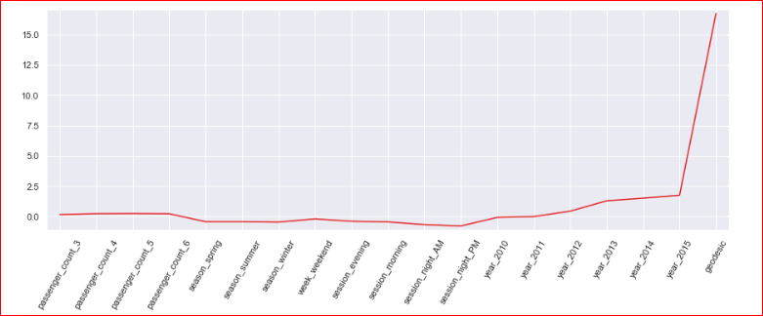

In [193]:
from sklearn.model_selection import cross_val_score
# Create a linear regression object: reg
reg = Linear Regression()

# Compute 5-fold cross-validation scores: cv_scores
cv_scores = cross_val_score(reg,X,y,cv=5,scoring='neg_mean_squared_error')

# Print the 5-fold cross-validation scores
print(cv_scores)

print("Average 5-Fold CV Score: {}".format(np.mean(cv_scores)))
[-5.30945311 -5.33924713 -5.10740884 -5.30298879 -5.42849547]
Average 5-Fold CV Score: -5.297518668356715

Decision Tree Regression

In [59]:
train.info()
<class 'pandas.core.frame.DataFrame'>
Int64Index: 15660 entries, 0 to 15660
Data columns (total 7 columns):
fare_amount 15660 non-null float64
passenger_count 15660 non-null category
year 15660 non-null category
month 15660 non-null category
day_of_week 15660 non-null category
hour 15660 non-null category
geodesic 15660 non-null float64
dtypes: category(5), float64(2)
memory usage: 445.7 KB

In [169]:
# Setup the parameters and distributions to sample from: param_dist
param_dist = {'max_depth': range(2,16,2),
'min_samples_split': range(2,16,2)}

# Instantiate a Decision Tree regressor: tree
tree = DecisionTreeRegressor()

# Instantiate the gridSearchCV object: tree_cv
tree_cv = GridSearchCV(tree, param_dist, cv=5)

# Fit it to the data
tree_cv.fit(X, y)

# Print the tuned parameters and score
print("Tuned Decision Tree Parameters: {}".format(tree_cv.best_params_))
print("Best score is {}".format(tree_cv.best_score_))
Tuned Decision Tree Parameters: {'max_depth': 6, 'min_samples_split': 2}
Best score is 0.7313489270203365
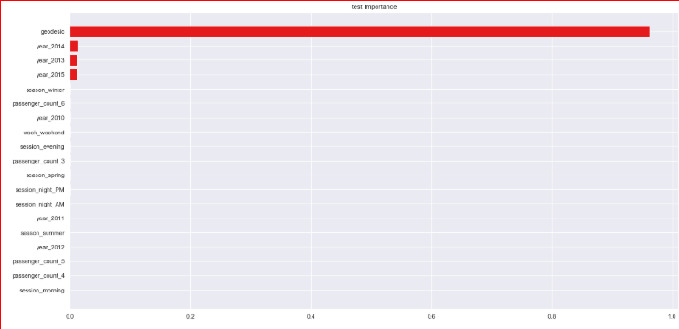

In [175]:
# Instantiate a tree regressor: tree
tree = DecisionTreeRegressor(max_depth= 6, min_samples_split=2)

# Fit the regressor to the data
tree.fit(X_train,y_train)

# Compute and print the coefficients
tree_features = tree.feature_importances_
print(tree_features)

# Sort test importances in descending order
indices = np.argsort(tree_features)[::1]

# Rearrange test names so they match the sorted test importances
names = [test.columns[i] for i in indices]

# Creating plot
fig = plt.figure(figsize=(20,10))
plt.title("test Importance")

# Add horizontal bars
plt.barh(range(pd.DataFrame(X_train).shape[1]),tree_features[indices],align = 'center')
plt.yticks(range(pd.DataFrame(X_train).shape[1]), names)
plt.savefig('tree test importance')
plt.show()
# Make predictions and cal error
test_scores(tree)
[2.84444261e-04 0.00000000e+00 0.00000000e+00 6.62482083e-04
1.61062372e-04 0.00000000e+00 7.12401788e-04 5.18985478e-04
3.70483099e-04 0.00000000e+00 0.00000000e+00 1.43606742e-04
6.34699189e-04 0.00000000e+00 0.00000000e+00 1.12205718e-02
1.19156808e-02 1.10211120e-02 9.62354470e-01]

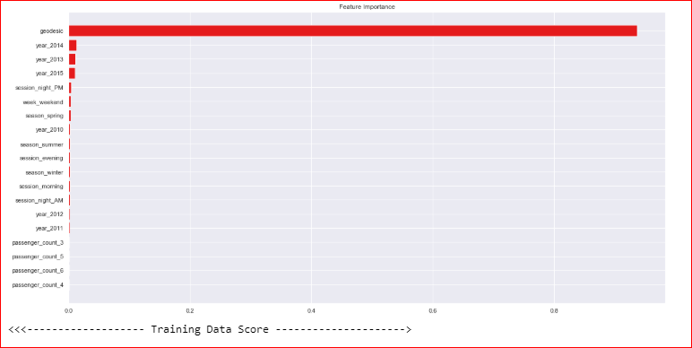

<<<------------------- Training Data Score --------------------->

r square 0.7471531379429529
Adjusted r square:0.7467434074202166
MAPE:18.54709262686637
MSE: 5.028919976577308
RMSE: 2.2425253569530286
RMSLE: 0.2087118879388543

<<<------------------- Test Data Score --------------------->

r square 0.7408782468914072
Adjusted r square:0.739614238339658
MAPE:19.072219163205943
MSE: 5.312990500038495
RMSE: 2.304992516265182
RMSLE: 0.2123390923855204

Random Forest Regression

In [171]:
# Create the random grid
random_grid = {'n_estimators': range(100,500,100),'max_depth': range(5,20,1), 'min_samples_leaf':range(2,5,1),'max_features':['auto','sqrt','log2'], 'bootstrap': [True, False],'min_samples_split': range(2,5,1)}

# Instantiate a Decision Forest classifier: Forest
Forest = RandomForestRegressor()

# Instantiate the gridSearchCV object: Forest_cv
Forest_cv = RandomizedSearchCV(Forest, random_grid, cv=5)

# Fit it to the data
Forest_cv.fit(X, y)

# Print the tuned parameters and score
print("Tuned Random Forest Parameters: {}".format(Forest_cv.best_params_))
print("Best score is {}".format(Forest_cv.best_score_))
Tuned Random Forest Parameters: {'n_estimators': 100, 'min_samples_split': 2, 'min_samples_leaf': 4, 'max_features': 'auto', 'max_depth': 9, 'bootstrap': True}
Best score is 0.7449373558797026

In [172]:
# Instantiate a Forest regressor: Forest
Forest = RandomForestRegressor(n_estimators=100, min_samples_split= 2, min_samples_leaf=4, max_features='auto', max_depth=9, bootstrap=True)

# Fit the regressor to the data
Forest.fit(X_train,y_train)

# Compute and print the coefficients
Forest_features = Forest.feature_importances_
print(Forest_features)

# Sort feature importances in descending order
indices = np.argsort(Forest_features)[::1]

# Rearrange feature names so they match the sorted feature importances
names = [test.columns[i] for i in indices]

# Creating plot
fig = plt.figure(figsize=(20,10))
plt.title("Feature Importance")

# Add horizontal bars
plt.barh(range(pd.DataFrame(X_train).shape[1]),Forest_features[indices],align = 'center')
plt.yticks(range(pd.DataFrame(X_train).shape[1]), names)
plt.savefig('Random forest feature importance')
plt.show()
# Make predictions
test_scores(Forest)
[8.38184957e-04 4.94135920e-04 7.11899115e-04 5.38216645e-04
2.80513240e-03 2.56688669e-03 2.45344190e-03 3.36652102e-03
2.55846601e-03 2.24548406e-03 2.10589565e-03 3.96233505e-03
2.60693816e-03 9.26615145e-04 1.73210920e-03 1.08242321e-02
1.24468718e-02 9.75989798e-03 9.37056736e-01]
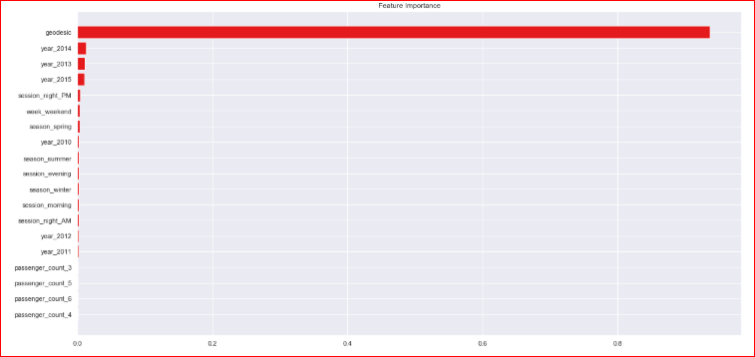

<<<------------------- Training Data Score --------------------->

r square 0.7893248033533271
Adjusted r square:0.7889834107105734
MAPE:16.95972203709288
MSE: 4.190159594493088
RMSE: 2.0469879321806195
RMSLE: 0.19142097538465247

<<<------------------- Test Data Score --------------------->

r square 0.7542305881615392
Adjusted r square: 0.7530317129818394
MAPE: 18.565011130411502
MSE: 5.039216255034242
RMSE: 2.2448198714004297
RMSLE: 0.20710042575083681

In [173]:
from sklearn.model_selection import cross_val_score
# Create a random forest regression object: Forest
Forest = RandomForestRegressor(n_estimators=400, min_samples_split= 2, min_samples_leaf=4, max_features='auto', max_depth=12, bootstrap=True)

# Compute 5-fold cross-validation scores: cv_scores
cv_scores = cross_val_score(Forest,X,y,cv=5,scoring='neg_mean_squared_error')

# Print the 5-fold cross-validation scores
print(cv_scores)

print("Average 5-Fold CV Score: {}".format(np.mean(cv_scores)))
[-5.19821639 -5.18058997 -5.11306209 -5.15194135 -5.14644304]
Average 5-Fold CV Score: -5.158050568861664

Improving accuracy using XGBOOST
- Improve Accuracy a) Algorithm Tuning b) Ensembles

In [176]:
data_dmatrix = xgb.DMatrix(data=X,label=y)
dtrain = xgb.DMatrix(X_train, label=y_train)
dtest = xgb.DMatrix(X_test)

In [177]:
dtrain,dtest, data_dmatrix
Out[177]:
(<xgboost.core.DMatrix at 0x1860091a0f0>,
<xgboost.core.DMatrix at 0x18600a11198>,
<xgboost.core.DMatrix at 0x18603856d68>)

In [179]:
params = {"objective":"reg:linear",'colsample_bytree': 0.3,'learning_rate': 0.1,
'max_depth': 5, 'alpha': 10}

cv_results = xgb.cv(dtrain=data_dmatrix, params=params, nfold=5,
num_boost_round=50,early_stopping_rounds=10,metrics="rmse", as_pandas=True, seed=123)
cv_results.head()
Out[179]:
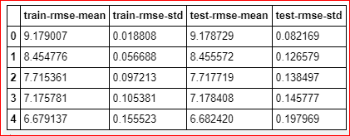

In [180]:
# the final boosting round metric
print((cv_results["test-rmse-mean"]).tail(1))
49 2.685997
Name: test-rmse-mean, dtype: float64

In [181]:
Xgb = XGBRegressor()
Xgb.fit(X_train,y_train)
# pred_xgb = model_xgb.predict(X_test)
test_scores(Xgb)
<<<------------------- Training Data Score --------------------->

r square 0.7608853411883156
Adjusted r square: 0.760497863276382
MAPE: 17.83934902657697
MSE: 4.7557975392996665
RMSE: 2.1807791129088856
RMSLE: 0.2012889741509688

<<<------------------- Test Data Score --------------------->

r square 0.7598553804648028
Adjusted r square:0.7586839432963385
MAPE:18.226158089842883
MSE: 4.923886423735188
RMSE: 2.2189831959109534
RMSLE: 0.20444191558083114

In [182]:
# Create the random grid
para = {'n_estimators': range(100,500,100),'max_depth': range(3,10,1), 'reg_alpha':np.logspace(-4, 0, 50),'subsample': np.arange(0.1,1,0.2),
'colsample_bytree': np.arange(0.1,1,0.2),'colsample_bylevel': np.arange(0.1,1,0.2),
'colsample_bynode': np.arange(0.1,1,0.2),'learning_rate': np.arange(.05, 1, .05)}

# Instantiate a Decision Forest classifier: Forest
Xgb = XGBRegressor()

# Instantiate the gridSearchCV object: Forest_cv
xgb_cv = RandomizedSearchCV(Xgb, para, cv=5)

# Fit it to the data
xgb_cv.fit(X, y)

# Print the tuned parameters and score
print("Tuned Xgboost Parameters: {}".format(xgb_cv.best_params_))
print("Best score is {}".format(xgb_cv.best_score_))
Tuned Xgboost Parameters: {'subsample': 0.1, 'reg_alpha': 0.08685113737513521, 'n_estimators': 200, 'max_depth': 3, 'learning_rate': 0.05, 'colsample_bytree': 0.7000000000000001, 'colsample_bynode': 0.7000000000000001, 'colsample_bylevel': 0.9000000000000001}
Best score is 0.7489532917329004

In [183]:
# Instantiate a xgb regressor: xgb
Xgb = XGBRegressor(subsample= 0.1, reg_alpha= 0.08685113737513521, n_estimators= 200, max_depth= 3, learning_rate=0.05, colsample_bytree= 0.7000000000000001, colsample_bynode=0.7000000000000001, colsample_bylevel=0.9000000000000001)

# Fit the regressor to the data
Xgb.fit(X_train,y_train)

# Compute and print the coefficients
xgb_features = Xgb.feature_importances_
print(xgb_features)

# Sort feature importances in descending order
indices = np.argsort(xgb_features)[::1]

# Rearrange feature names so they match the sorted feature importances
names = [test.columns[i] for i in indices]

# Creating plot
fig = plt.figure(figsize=(20,10))
plt.title("Feature Importance")

# Add horizontal bars
plt.barh(range(pd.DataFrame(X_train).shape[1]),xgb_features[indices],align = 'center')
plt.yticks(range(pd.DataFrame(X_train).shape[1]), names)
plt.savefig(' xgb feature importance')
plt.show()# Make predictions
test_scores(Xgb)
[0.01751499 0.01810841 0.01622883 0.02114999 0.02419355 0.02690452
0.0170655 0.01812746 0.01990535 0.01504988 0.02823743 0.01952868
0.03171849 0.02106621 0.01852263 0.04723873 0.05193354 0.03770861
0.5497972 ]
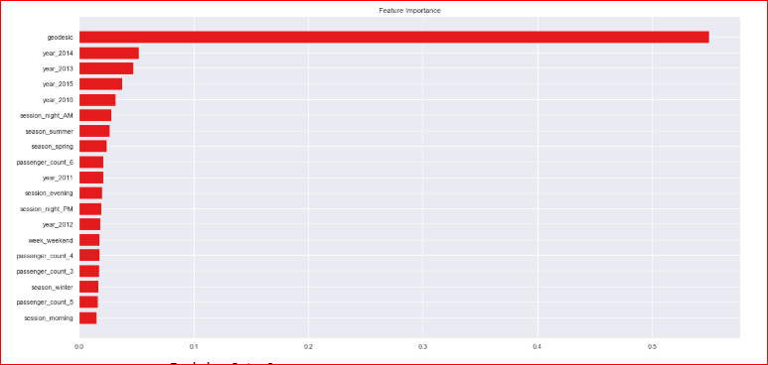

<<<------------------- Training Data Score --------------------->

r square 0.7542254447407496
Adjusted r square:0.7538271746725257
MAPE:18.15955543560476
MSE: 4.8882575034638425
RMSE: 2.2109404115588105
RMSLE: 0.20479785952792007

<<<------------------- Test Data Score --------------------->

r square 0.7587122269269724
Adjusted r square:0.7575352133997868
MAPE:18.37149036944938
MSE: 4.947325458913502
RMSE: 2.2242584065062005
RMSLE: 0.20534539640609023

Finalize model
- Create standalone model on entire training dataset
- Save model for later use

In [184]:
def rmsle(y,y_):
log1 = np.nan_to_num(np.array([np.log(v + 1) for v in y]))
log2 = np.nan_to_num(np.array([np.log(v + 1) for v in y_]))
calc = (log1 - log2) ** 2
return np.sqrt(np.mean(calc))
def score(y, y_):
print('r square ', metrics.r2_score(y, y_))
print('Adjusted r square:{}'.format(1 - (1-metrics.r2_score(y, y_))*(len(y)-1)/(len(y)-X_train.shape[1]-1)))
print('MAPE:{}'.format(np.mean(np.abs((y - y_) / y))*100))
print('MSE:', metrics.mean_squared_error(y, y_))
print('RMSE:', np.sqrt(metrics.mean_squared_error(y, y_)))
print('RMSLE:',rmsle(y_test,y_pred))
def scores(model):
print('<<<------------------- Training Data Score --------------------->')
print()
#Predicting result on Training data
y_pred = model.predict(X)
score(y,y_pred)
print('RMSLE:',rmsle(y,y_pred))

In [185]:
test.columns
Out[185]:
Index(['passenger_count_3', 'passenger_count_4', 'passenger_count_5',
'passenger_count_6', 'season_spring', 'season_summer', 'season_winter',
'week_weekend', 'session_evening', 'session_morning',
'session_night_AM', 'session_night_PM', 'year_2010', 'year_2011',
'year_2012', 'year_2013', 'year_2014', 'year_2015', 'geodesic'],
dtype='object')

In [186]:
train.columns
Out[186]:
Index(['fare_amount', 'passenger_count_3', 'passenger_count_4',
'passenger_count_5', 'passenger_count_6', 'season_spring',
'season_summer', 'season_winter', 'week_weekend', 'session_evening',
'session_morning', 'session_night_AM', 'session_night_PM', 'year_2010',
'year_2011', 'year_2012', 'year_2013', 'year_2014', 'year_2015',
'geodesic'],
dtype='object')

In [194]:
train.shape
Out[194]:
(15660, 20)

In [195]:
test.shape
Out[195]:
(9914, 19)

In [187]:
a=pd.read_csv('test.csv')

In [188]:
test_pickup_datetime=a['pickup_datetime']

In [192]:
# Instantiate a xgb regressor: xgb
Xgb = XGBRegressor(subsample= 0.1, reg_alpha= 0.08685113737513521, n_estimators= 200, max_depth= 3, learning_rate=0.05, colsample_bytree= 0.7000000000000001, colsample_bynode=0.7000000000000001, colsample_bylevel=0.9000000000000001)

# Fit the regressor to the data
Xgb.fit(X,y)

# Compute and print the coefficients
xgb_features = Xgb.feature_importances_
print(xgb_features)

# Sort feature importances in descending order
indices = np.argsort(xgb_features)[::1]

# Rearrange feature names so they match the sorted feature importances
names = [test.columns[i] for i in indices]

# Creating plot
fig = plt.figure(figsize=(20,10))
plt.title("Feature Importance")

# Add horizontal bars
plt.barh(range(pd.DataFrame(X_train).shape[1]),xgb_features[indices],align = 'center')
plt.yticks(range(pd.DataFrame(X_train).shape[1]), names)
plt.savefig(' xgb1 feature importance')
plt.show()
scores(Xgb)

# Predictions
pred = Xgb.predict(test.values)
pred_results_wrt_date = pd.DataFrame({"pickup_datetime":test_pickup_datetime,"fare_amount" : pred})
pred_results_wrt_date.to_csv("predictions_xgboost.csv",index=False)
[0.01415076 0.01866597 0.01274582 0.01364598 0.01662278 0.0213572
0.01617201 0.01989506 0.01398486 0.02389306 0.02976851 0.02008079
0.02590016 0.02744447 0.02047656 0.0408919 0.04868058 0.03846469
0.57715887]
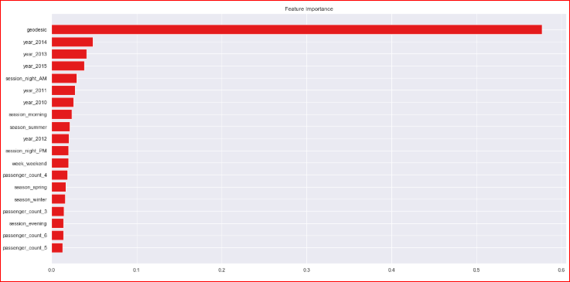

<<<------------------- Training Data Score --------------------->

r square 0.7564292952182666
Adjusted r square:0.7561333973032505
MAPE:18.100202501103993
MSE: 4.881882644209386
RMSE: 2.2094982788428204
RMSLE: 0.2154998534679604
RMSLE: 0.20415655796958632

In [236]:
pred_results_wrt_date
Out[236]:
9914 rows × 2 columns

In [193]:
# Save the model as a pickle in a file
joblib.dump(Xgb, 'cab_fare_xgboost_model.pkl')

# # Load the model from the file
# Xgb_from_joblib = joblib.load('cab_fare_xgboost_model.pkl')
Out[193]:
['cab_fare_xgboost_model.pkl']

Complete R-Code
# Cab Fare Prediction
rm(list = ls())
setwd("C:/Users/admin/Documents/R files")
# #loading Libraries
x = c("ggplot2", "corrgram", "DMwR", "usdm", "caret", "randomForest", "e1071",
"DataCombine", "doSNOW", "inTrees", "rpart.plot", "rpart",'MASS','xgboost','stats')
#load Packages
lapply(x, require, character.only = TRUE)
rm(x)
# The details of data attributes in the dataset are as follows:
# pickup_datetime - timestamp value indicating when the cab ride started.
# pickup_longitude - float for longitude coordinate of where the cab ride started.
# pickup_latitude - float for latitude coordinate of where the cab ride started.
# dropoff_longitude - float for longitude coordinate of where the cab ride ended.
# dropoff_latitude - float for latitude coordinate of where the cab ride ended.
# passenger_count - an integer indicating the number of passengers in the cab ride.
# loading datasets
train = read.csv("train_cab.csv", header = T, na.strings = c(" ", "", "NA"))
test = read.csv("test.csv")
test_pickup_datetime = test["pickup_datetime"]
# Structure of data
str(train)
str(test)
summary(train)
summary(test)
head(train,5)
head(test,5)
######## Exploratory Data Analysis #######################
# Changing the data types of variables
train$fare_amount = as.numeric(as.character(train$fare_amount))
train$passenger_count=round(train$passenger_count)
### Removing values which are not within desired range(outlier) depending upon basic understanding of dataset.
# 1.Fare amount has a negative value, which doesn't make sense. A price amount cannot be -ve and also cannot be 0. So we will remove these fields.
train[which(train$fare_amount < 1 ),]
nrow(train[which(train$fare_amount < 1 ),])
train = train[-which(train$fare_amount < 1 ),]
#2.Passenger_count variable
for (i in seq(4,11,by=1)){
print(paste('passenger_count above ' ,i,nrow(train[which(train$passenger_count > i ),])))
}
# so 20 observations of passenger_count is consistenly above from 6,7,8,9,10 passenger_counts, let's check them.
train[which(train$passenger_count > 6 ),]
# Also we need to see if there are any passenger_count==0
train[which(train$passenger_count <1 ),]
nrow(train[which(train$passenger_count <1 ),])
# We will remove these 58 observations and 20 observation which are above 6 value because a cab cannot hold these number of passengers.
train = train[-which(train$passenger_count < 1 ),]
train = train[-which(train$passenger_count > 6),]
# 3.Latitudes range from -90 to 90.Longitudes range from -180 to 180.Removing which does not satisfy these ranges
print(paste('pickup_longitude above 180=',nrow(train[which(train$pickup_longitude >180 ),])))
print(paste('pickup_longitude above -180=',nrow(train[which(train$pickup_longitude < -180 ),])))
print(paste('pickup_latitude above 90=',nrow(train[which(train$pickup_latitude > 90 ),])))
print(paste('pickup_latitude above -90=',nrow(train[which(train$pickup_latitude < -90 ),])))
print(paste('dropoff_longitude above 180=',nrow(train[which(train$dropoff_longitude > 180 ),])))
print(paste('dropoff_longitude above -180=',nrow(train[which(train$dropoff_longitude < -180 ),])))
print(paste('dropoff_latitude above -90=',nrow(train[which(train$dropoff_latitude < -90 ),])))
print(paste('dropoff_latitude above 90=',nrow(train[which(train$dropoff_latitude > 90 ),])))
# There's only one outlier which is in variable pickup_latitude.So we will remove it with nan.
# Also we will see if there are any values equal to 0.
nrow(train[which(train$pickup_longitude == 0 ),])
nrow(train[which(train$pickup_latitude == 0 ),])
nrow(train[which(train$dropoff_longitude == 0 ),])
nrow(train[which(train$pickup_latitude == 0 ),])
# there are values which are equal to 0. we will remove them.
train = train[-which(train$pickup_latitude > 90),]
train = train[-which(train$pickup_longitude == 0),]
train = train[-which(train$dropoff_longitude == 0),]
# Make a copy
df=train
# train=df
####### Missing Value Analysis #######
missing_val = data.frame(apply(train,2,function(x){sum(is.na(x))}))
missing_val$Columns = row.names(missing_val)
names(missing_val)[1] = "Missing_percentage"
missing_val$Missing_percentage = (missing_val$Missing_percentage/nrow(train)) * 100
missing_val = missing_val[order(-missing_val$Missing_percentage),]
row.names(missing_val) = NULL
missing_val = missing_val[,c(2,1)]
missing_val
unique(train$passenger_count)
unique(test$passenger_count)
train[,'passenger_count'] = factor(train[,'passenger_count'], labels=(1:6))
test[,'passenger_count'] = factor(test[,'passenger_count'], labels=(1:6))
# 1.For Passenger_count:
# Actual value = 1
# Mode = 1
# KNN = 1
train$passenger_count[1000]
train$passenger_count[1000] = NA
getmode <- function(v) {
uniqv <- unique(v)
uniqv[which.max(tabulate(match(v, uniqv)))]
}
# Mode Method
getmode(train$passenger_count)
# We can't use mode method because data will be more biased towards passenger_count=1
# 2.For fare_amount:
# Actual value = 18.1,
# Mean = 15.117,
# Median = 8.5,
# KNN = 18.28
sapply(train, sd, na.rm = TRUE)
# fare_amount pickup_datetime pickup_longitude
# 435.968236 4635.700531 2.659050
# pickup_latitude dropoff_longitude dropoff_latitude
# 2.613305 2.710835 2.632400
# passenger_count
# 1.266104
train$fare_amount[1000]
train$fare_amount[1000]= NA
# Mean Method
mean(train$fare_amount, na.rm = T)
#Median Method
median(train$fare_amount, na.rm = T)
# kNN Imputation
train = knnImputation(train, k = 181)
train$fare_amount[1000]
train$passenger_count[1000]
sapply(train, sd, na.rm = TRUE)
# fare_amount pickup_datetime pickup_longitude
# 435.661952 4635.700531 2.659050
# pickup_latitude dropoff_longitude dropoff_latitude
# 2.613305 2.710835 2.632400
# passenger_count
# 1.263859
sum(is.na(train))
str(train)
summary(train)
df1=train
# train=df1
####### Outlier Analysis #######
# We Will do Outlier Analysis only on Fare_amount just for now and we will do outlier analysis after feature engineering latitudes and longitudes.
# Boxplot for fare_amount
pl1 = ggplot(train,aes(x = factor(passenger_count),y = fare_amount))
pl1 + geom_boxplot(outlier.colour="red", fill = "grey" ,outlier.shape=18,outlier.size=1, notch=FALSE)+ylim(0,100)
# Replace all outliers with NA and impute
vals = train[,"fare_amount"] %in% boxplot.stats(train[,"fare_amount"])$out
train[which(vals),"fare_amount"] = NA
#lets check the NA's
sum(is.na(train$fare_amount))
#Imputing with KNN
train = knnImputation(train,k=3)
# lets check the missing values
sum(is.na(train$fare_amount))
str(train)
df2=train
# train=df2
####### Feature Engineering #######
# 1.Feature Engineering for timestamp variable
# we will derive new features from pickup_datetime variable
# new features will be year,month,day_of_week,hour
#Convert pickup_datetime from factor to date time
train$pickup_date = as.Date(as.character(train$pickup_datetime))
train$pickup_weekday = as.factor(format(train$pickup_date,"%u"))# Monday = 1
train$pickup_mnth = as.factor(format(train$pickup_date,"%m"))
train$pickup_yr = as.factor(format(train$pickup_date,"%Y"))
pickup_time = strptime(train$pickup_datetime,"%Y-%m-%d %H:%M:%S")
train$pickup_hour = as.factor(format(pickup_time,"%H"))
#Add same features to test set
test$pickup_date = as.Date(as.character(test$pickup_datetime))
test$pickup_weekday = as.factor(format(test$pickup_date,"%u"))# Monday = 1
test$pickup_mnth = as.factor(format(test$pickup_date,"%m"))
test$pickup_yr = as.factor(format(test$pickup_date,"%Y"))
pickup_time = strptime(test$pickup_datetime,"%Y-%m-%d %H:%M:%S")
test$pickup_hour = as.factor(format(pickup_time,"%H"))
sum(is.na(train))# there was 1 'na' in pickup_datetime which created na's in above feature engineered variables.
train = na.omit(train) # we will remove that 1 row of na's
train = subset(train,select = -c(pickup_datetime,pickup_date))
test = subset(test,select = -c(pickup_datetime,pickup_date))
# Now we will use month,weekday,hour to derive new features like sessions in a day,seasons in a year,week:weekend/weekday
# f = function(x){
# if ((x >=5)& (x <= 11)){
# return ('morning')
# }
# if ((x >=12) & (x <= 16)){
# return ('afternoon')
# }
# if ((x >=17) & (x <= 20)){
# return ('evening')
# }
# if ((x >=21) & (x <= 23)){
# return ('night (PM)')
# }
# if ((x >=0) & (x <= 4)){
# return ('night (AM)')
# }
# }
# 2.Calculate the distance travelled using longitude and latitude
deg_to_rad = function(deg){
(deg * pi) / 180
}
haversine = function(long1,lat1,long2,lat2){
#long1rad = deg_to_rad(long1)
phi1 = deg_to_rad(lat1)
#long2rad = deg_to_rad(long2)
phi2 = deg_to_rad(lat2)
delphi = deg_to_rad(lat2 - lat1)
dellamda = deg_to_rad(long2 - long1)
a = sin(delphi/2) * sin(delphi/2) + cos(phi1) * cos(phi2) *
sin(dellamda/2) * sin(dellamda/2)
c = 2 * atan2(sqrt(a),sqrt(1-a))
R = 6371e3
R * c / 1000 #1000 is used to convert to meters
}
# Using haversine formula to calculate distance fr both train and test
train$dist = haversine(train$pickup_longitude,train$pickup_latitude,train$dropoff_longitude,train$dropoff_latitude)
test$dist = haversine(test$pickup_longitude,test$pickup_latitude,test$dropoff_longitude,test$dropoff_latitude)
# We will remove the variables which were used to feature engineer new variables
train = subset(train,select = -c(pickup_longitude,pickup_latitude,dropoff_longitude,dropoff_latitude))
test = subset(test,select = -c(pickup_longitude,pickup_latitude,dropoff_longitude,dropoff_latitude))
str(train)
summary(train)
####### Feature selection #########
numeric_index = sapply(train,is.numeric) #selecting only numeric
numeric_data = train[,numeric_index]
cnames = colnames(numeric_data)
#Correlation analysis for numeric variables
corrgram(train[,numeric_index],upper.panel=panel.pie, main = "Correlation Plot")
#ANOVA for categorical variables with target numeric variable
#aov_results = aov(fare_amount ~ passenger_count * pickup_hour * pickup_weekday,data = train)
aov_results = aov(fare_amount ~ passenger_count + pickup_hour + pickup_weekday + pickup_mnth + pickup_yr,data = train)
summary(aov_results)
# pickup_weekdat has p value greater than 0.05
train = subset(train,select=-pickup_weekday)
#remove from test set
test = subset(test,select=-pickup_weekday)
######## Feature Scaling ########
#Normality check
# qqnorm(train$fare_amount)
# histogram(train$fare_amount)
library(car)
# dev.off()
par(mfrow=c(1,2))
qqPlot(train$fare_amount) # qqPlot, it has a x values derived from gaussian distribution, if data is distributed normally then the sorted data points should lie very close to the solid reference line
truehist(train$fare_amount) # truehist() scales the counts to give an estimate of the probability density.
lines(density(train$fare_amount)) # Right skewed # lines() and density() functions to overlay a density plot on histogram
#Normalisation
print('dist')
train[,'dist'] = (train[,'dist'] - min(train[,'dist']))/
(max(train[,'dist'] - min(train[,'dist'])))
# #check multicollearity
# library(usdm)
# vif(train[,-1])
#
# vifcor(train[,-1], th = 0.9)
######## Splitting train into train and validation subsets #########
set.seed(1000)
tr.idx = createDataPartition(train$fare_amount,p=0.75,list = FALSE) # 75% in trainin and 25% in Validation Datasets
train_data = train[tr.idx,]
test_data = train[-tr.idx,]
rmExcept(c("test","train","df",'df1','df2','df3','test_data','train_data','test_pickup_datetime'))
#####Model Selection################
#Error metric used to select model is RMSE
############# Linear regression #################
lm_model = lm(fare_amount ~.,data=train_data)
summary(lm_model)
str(train_data)
plot(lm_model$fitted.values,rstandard(lm_model),main = "Residual plot",
xlab = "Predicted values of fare_amount",
ylab = "standardized residuals")
lm_predictions = predict(lm_model,test_data[,2:6])
qplot(x = test_data[,1], y = lm_predictions, data = test_data, color = I("blue"), geom = "point")
regr.eval(test_data[,1],lm_predictions)
# mae mse rmse mape
# 3.5303114 19.3079726 4.3940838 0.4510407
###### Decision Tree ##########
Dt_model = rpart(fare_amount ~ ., data = train_data, method = "anova")
summary(Dt_model)
#Predict for new test cases
predictions_DT = predict(Dt_model, test_data[,2:6])
qplot(x = test_data[,1], y = predictions_DT, data = test_data, color = I("blue"), geom = "point")
regr.eval(test_data[,1],predictions_DT)
# mae mse rmse mape
# 1.8981592 6.7034713 2.5891063 0.2241461
############# Random forest ##########
rf_model = randomForest(fare_amount ~.,data=train_data)
summary(rf_model)
rf_predictions = predict(rf_model,test_data[,2:6])
qplot(x = test_data[,1], y = rf_predictions, data = test_data, color = I("blue"), geom = "point")
regr.eval(test_data[,1],rf_predictions)
# mae mse rmse mape
# 1.9053850 6.3682283 2.5235349 0.2335395
####### Improving Accuracy by using Ensemble technique ---- XGBOOST ######
train_data_matrix = as.matrix(sapply(train_data[-1],as.numeric))
test_data_data_matrix = as.matrix(sapply(test_data[-1],as.numeric))
xgboost_model = xgboost(data = train_data_matrix,label = train_data$fare_amount,nrounds = 15,verbose = FALSE)
summary(xgboost_model)
xgb_predictions = predict(xgboost_model,test_data_data_matrix)
qplot(x = test_data[,1], y = xgb_predictions, data = test_data, color = I("blue"), geom = "point")
regr.eval(test_data[,1],xgb_predictions)
# mae mse rmse mape
# 1.6183415 5.1096465 2.2604527 0.1861947
####### Finalizing and Saving Model for later use ########
# In this step we will train our model on whole training Dataset and save that model for later use
train_data_matrix2 = as.matrix(sapply(train[-1],as.numeric))
test_data_matrix2 = as.matrix(sapply(test,as.numeric))
xgboost_model2 = xgboost(data = train_data_matrix2,label = train$fare_amount,nrounds = 15,verbose = FALSE)
# Saving the trained model
saveRDS(xgboost_model2, "./final_Xgboost_model_using_R.rds")
# loading the saved model
super_model <- readRDS("./final_Xgboost_model_using_R.rds")
print(super_model)
# Lets now predict on test dataset
xgb = predict(super_model,test_data_matrix2)
xgb_pred = data.frame(test_pickup_datetime,"predictions" = xgb)
# Now lets write(save) the predicted fare_amount in disk as .csv format
write.csv(xgb_pred,"xgb_predictions_R.csv",row.names = FALSE)

